TASK 1:
Entities:
- Books
- Transactions
- Patrons
Relationships:
- A Book can be borrowed many times → (1 : M with Transactions)
- A Patron can borrow many books → (1 : M with Transactions)
- Transactions acts as a bridge entity
Logical Model:
Books (BookID, Title, AuthorName, Rating)
Patrons (PatronID, Name, ContactNo, Address)
Transactions (TransactionID, BookID, PatronID, IssueDate, ReturnDate)

TASK 2:
Domain Name | Type | Constraint
ID_DOMAIN | NUMBER | NOT NULL
NAME_DOMAIN | VARCHAR2(100) | NOT NULL
ADDRESS_DOMAIN | VARCHAR2(200) | NULL
CONTACT_DOMAIN | VARCHAR2(15) | NOT NULL
DATE_DOMAIN | DATE | NOT NULL
RATING_DOMAIN | NUMBER(2,1) | CHECK (Rating BETWEEN 0 AND 5)

Books | Patrons | Transactions
BookID (PK) | PatronID (PK) | TransactionID (PK)
Title | Name | BookID (FK)
AuthorName | ContactNo | PatronID (FK)
Rating | Address | IssueDate
 |  | ReturnDate

TASK 4:
Relationships
- Books → Transactions (1:M)
- Patrons → Transactions (1:M)
Business Rules
- A book cannot be issued to more than one person at the same time
- A patron can borrow multiple books simultaneously
Implementation Logic
- Enforce rule using:
  - UNIQUE constraint on active borrow
  - OR check using ReturnDate NULL condition

TASK 5:
BOOKS(BookID PK, Title, AuthorName, Rating)
PATRONS(PatronID PK, Name, ContactNo, Address)
TRANSACTIONS(TransactionID PK, BookID FK, PatronID FK, IssueDate, ReturnDate)

TASK 6:
CREATE TABLE Books (
BookID NUMBER PRIMARY KEY,
Title VARCHAR2(100) NOT NULL,
AuthorName VARCHAR2(100) NOT NULL,
Rating NUMBER(2,1),
CONSTRAINT chk_rating CHECK (Rating BETWEEN 0 AND 5)
);
CREATE TABLE Patrons (
PatronID NUMBER PRIMARY KEY,
Name VARCHAR2(100) NOT NULL,
ContactNo VARCHAR2(15) NOT NULL,
Address VARCHAR2(200)
);
CREATE TABLE Transactions (
TransactionID NUMBER PRIMARY KEY,
BookID NUMBER,
PatronID NUMBER,
IssueDate DATE NOT NULL,
ReturnDate DATE,
CONSTRAINT fk_book
FOREIGN KEY (BookID) REFERENCES Books(BookID),
CONSTRAINT fk_patron
FOREIGN KEY (PatronID) REFERENCES Patrons(PatronID),
CONSTRAINT chk_dates
CHECK (ReturnDate IS NULL OR ReturnDate > IssueDate)
);

TASK 7:
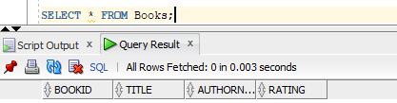
SELECT * FROM Books;

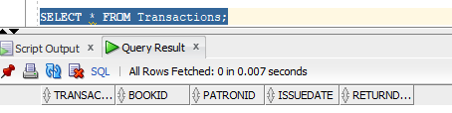
SELECT * FROM Transactions;

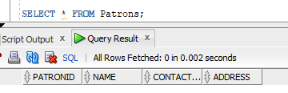
SELECT * FROM Patrons;

TASK 8:
New Entity: Authors
- Authors (AuthorID PK, AuthorName)
Updated Relationship:
- One Author → Many Books (1:M)
CREATE TABLE Authors (
AuthorID NUMBER PRIMARY KEY,
AuthorName VARCHAR2(100) NOT NULL
);
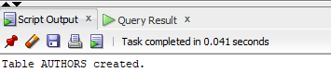
CREATE TABLE Books (
BookID NUMBER PRIMARY KEY,
Title VARCHAR2(100) NOT NULL,
AuthorID NUMBER,
Rating NUMBER(2,1),
CONSTRAINT fk_author
FOREIGN KEY (AuthorID) REFERENCES Authors(AuthorID),
CONSTRAINT chk_rating CHECK (Rating BETWEEN 0 AND 5)
);
TASK 9:
ALTER TABLE Transactions
ADD CONSTRAINT chk_return_after_issue
CHECK (ReturnDate IS NULL OR ReturnDate > IssueDate);

